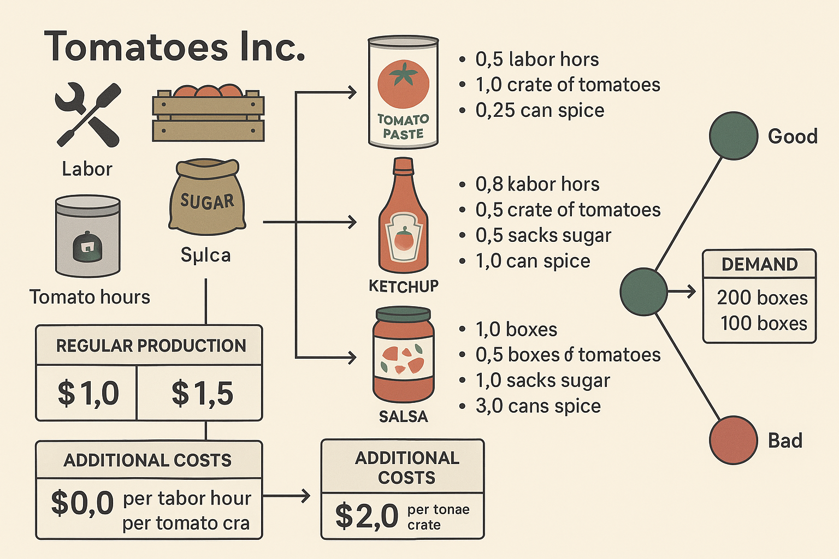

1. **Provide a general formulation for a deterministic LP model using paper (neatly handwritten or in Word). Define your notation clearly.**

Set $p∈\left\{P,K,S\right\}:Product Types P=tomato Paste, K=Katchap, S=Salsa$

$$Set t∈\left\{1,2,3\right\}Time Period (1,2,3)$$

Set $r∈\left\{L,T,SU,SP\right\}, L=Labor hours, T=Tomato crates,SU=Sugar sack, Sp=Spice cans$

**Parameters**

$$a_{pt}=Amount of resource r needed to produce one box of product p$$

$$R_{r}​: Regular supply of resource r per period {.R}_{L}=200, R_{T}=250, R_{su}=300, R_{sp}=100$$

$$CP_{P}​: Regular production cost per box CP_{p}=1.0, CP_{k}=1.5, CP_{s}=2.5$$

$$CR_{r}​:Cost of extra resource r per unit CR_{L}=2.0, CR_{T}=0.5, CR_{su}=1.0 , CR_{Sp}=1.0$$

$$CU_{p}:Unmet demand penalty per box.CU_{P}=2.0, CU_{K}=3, CU_{s}=6$$

$CS_{p}:$*Storage cost per box $.CS_{p}=0.5,CS_{k}=0.25, CS_{s}=0.2$*

$$d_{p}=200,d_{k}=40,d_{s}=20$$

**This is the model that gives numbers to the parameters**

1. Definition of decision variables:
$$x_{pt}=The Number of Box of Product P to Produce in time period t, p∈P, t∈T$$

$$S_{pt}=Number of boxes of Product p to store at the end of the period t, p∈P, t∈T$$

$$e_{rt}=Extra amount of resource r to use in the period t,p∈P, t∈T$$

$$u_{pt}=Unmet demand \left(shortage\right)for the product p in period t;, p∈P, t∈T$$

2. Objective Function:
$$min \sum_{t=1}^{3}{\left[\sum_{p}{CP_{p}*x_{pt}+\sum_{r}{CR_{r}}*e_{rt}+\sum_{p}{CS_{p}*S_{pt}+\sum_{P}{CU_{p}*u_{pt}+CU_{p}*u_{pt}}}}\right]}$$

3. Constraints:

$\sum_{P}{a_{pr}*x_{pt}≤R_{r}+e_{rt}} , ∀r∈R, t∈T$ (Resource Constraints)

$$x_{p1}=d_{p1}-u_{p1}+S_{p,1}\left(for t=1, Inventory Balance constraints\right)$$

$$x_{pt}+S_{p,t-1}=d_{pt}+S_{pt}-u_{pt}(for t=2 \& t=3 Inventory Balance constraints)$$

$x_{pt},S_{pt},u_{pt}$, $e_{rt}≥0 (sign Constraints)$

1. **Answer the following 3 questions using neat handwriting or in Word**

**1. When the first stage occur and what are the first-stage  
variables?**

The first stage occurs before the demand is known (i.e., before the uncertainty is revealed). This is the planning stage where the company decides how much to produce and whether to procure extra resources without knowing the exact demand scenario (good or bad economy).

First-stage decision variables:

$$x_{pt}=The Number of Box of Product P to Produce in time period t, p∈P, t∈T$$

$$e_{rt}=Extra amount of resource r to use in the period t,p∈P, t∈T$$

**2. When the second stage occur and what are the second- stage or recourse variables**

The second stage occurs after the demand is realized in each period. At this point, the company knows whether it is facing a good or bad demand scenario and reacts accordingly.

Second-stage (recourse) variables:

There are 8 possible scenarios (s=GGG, GGB, ..., BBB)

$S_{pts}=Units of product P to store at the end of period t under scenario$ s

$$u_{pts}=Units of unmet demand for product p in period t under scenario s$$

**3. What is the random variable**

The random variable is the product demand $d_{pts}$ which varies across scenarios.

In good period: $d_{Paste ,t, Good}$ =200 $d_{ketchup ,t, Good}=40$ $d_{Salsa ,t, Good}=20$.

In Bad period: $d_{Paste ,t, Bad}$ =100 $d_{ketchup ,t, Bad}=30$ $d_{Salsa ,t, Bad}=5$.

1. **Provide the extensive formulation (i.e., the deterministic equivalent formulation) of a two-stage stochastic model for solving the problem of minimizing the  
   expected cost. Define only any new notation using paper(neatly handwritten or Word)**

New Set : s $∈Senarios$

New Parameter $d_{pts}=realized demand of product p in period t under scenario s$

$$p_{s}=Probability of the scenario s$$

Objective Function:

$$\min\left[\sum_{t=1}^{3}{\left(\sum_{p}{CP_{p}*x_{pt}+\sum_{r}{CR_{r}}*e_{rt}}\right)+\sum_{s∈S}{P_{s}*\sum_{t=1}^{3}{\sum_{P}{(CS_{p}*S_{pts}+CU_{p}*u_{pts})}} }}\right]$$

Constraints:

$\sum_{P}{a_{pr}*x_{pt}≤R_{r}+e_{rt}} , ∀r∈R, t∈T$ (Resource Constraints)

$$x_{p1}=d_{p1s}-u_{p1s}+S_{p1s}\left(for t=1, Inventory Balance constraints\right) ∀p∈P. s∈S$$

$$x_{pt}+S_{p,t-1,s}=d_{pts}+S_{pts}-u_{pts}\left(for t=2 \& t=3 Inventory Balance constraints\right)∀p∈P. s∈S$$

Sign Constraints: $x_{pt},e_{rt}≥0 ∀p∈P. r∈R, ∀t ∈T$

$$S_{pts},u_{pts}≥0 ∀p∈P. s∈S , ∀t ∈T$$

**Value of the Stochastic Solution (VSS) Calculations**

**Optimal Solution to the TSSP model Optimal Expected Cost: $895.82**

**Optimal Solution with mean demand value Optimal Total Cost: $731.25**

**=== Value of Stochastic Solution ===**

**Stochastic Solution (SS) Cost: 895.82**

**Expected Value Problem (EV) Cost: 731.25**

**Expected Result of EV Solution (EEV) Cost: 953.69**

**Value of Stochastic Solution (VSS): 57.86**

Value for 1st stage decision variable is found using mean demands:

('Paste' to produce in 1st period ): 180,

('Paste' to produce in 2nd period ): 140,

('Paste' to produce in 3rd period ): 130,

('Ketchup' to produce in 1st period ): 50,

('Ketchup' to Produce in 2nd period): 35,

('Ketchup' to produce in 3rd period ): 30,

('Salsa' to produce in 1st period ): 15,

('Salsa' to produce in 2nd period ): 12.5,

('Salsa' to produce in 3rd period ): 10

**General Two-Stage Stochastic Programming Formulation:**

